**2018 Report on N-tracking NREC project 2015-3-360422-56, February 2019**

**Modeling soil N**

Dr. Cameron Pittelkow, Department of Crop Sciences, University of Illinois

**Summary**

With a long-term vision of developing a model-based N management tool in Illinois, the objectives of this portion of the project were to 1) calibrate a well-established publicly available crop model (Decision Support System for Agrotechnology Transfer: DSSAT) using soil N concentration data from three experimental sites in Illinois during 2015–2016; 2) evaluate DSSAT model performance against three independent field experiments and an additional dataset consisting of soil N concentration for 49 commercial maize fields; and 3) assess the model’s ability to predict the impacts of rainfall variability on the decrease in soil N concentration early in the maize growing season.

Overall, the model performance was determined to be “fair” in predicting soil N concentration in response to fertilizer management, weather patterns, and soil types. The DSSAT model was able to estimate SOM mineralization and the resulting increase in soil N concentration in April and May in the control treatments. At two experimental sites with fall N application, DSSAT accurately predicted soil N difference between the 224-Fall and 224-Spring treatments at maize planting (range of 5.9–11.2 mg N kg soil-1), likely owing to greater loss of fall-applied N from the 0–60 cm soil depth. Predictions also captured the decline in soil N concentration after maize planting due to active crop N uptake and spring environmental losses across the 224-Fall and 224-Spring treatments (the decrease in soil N concentration by mid-June was 12.9–38.1% and 1.0–55.7% for the observed and predicted values, respectively, during 2015–2017). The model performed well against observations from 49 commercial fields (R2 ranging from 0.69–0.88 across four rainfall categories). These results suggest that DSSAT has the potential to predict soil N concentration across fertilizer management, weather patterns, and soil types in Illinois maize production systems with reasonable accuracy, thereby providing an additional source of information to farmers interested in making in-season N management decisions.

**Methods**

To perform DSSAT simulations, four primary datasets are required including soil profile information, daily weather parameters, soil initial conditions, and crop management information. Weather parameters such as daily solar radiation, maximum air temperature, minimum air temperature, rainfall amount, pan evaporation, and relative humidity were obtained from 19 weather stations in the Illinois Climate Network. We used data from the most proximate weather station in order to generate input files for DSSAT simulations at a particular field.

We used the Gridded Soil Survey Geographic data (gSSURGO) dataset to obtain soil parameters such as texture, bulk density, soil organic C (SOC), albedo, drainage constants, and runoff curve number. SOM pools are determined based on the SOC, bulk density, and the thickness of soil layers. Each year, soil initial conditions (soil ammonium and nitrate concentration) were defined based on data from six field experiments designed to track soil N status in Illinois. When entering crop management information at all sites, it was assumed that dry seed was planted at 4 cm depth in rows with a plant population of 8 plants m-2 at seeding. For model calibration, input data for fertilizer source, amount, time, and method of application were set similar to the individual field trials described below.

We used soil N concentration in the maize growing season from six field experiments during 2015–2017 for DSSAT calibration and validation procedures. The DSSAT calibration process typically involves improvements in the six genotype coefficients (P1, P2, P5, G2, G3, and PHINT), which primarily reduce differences between observed and modeled crop phenology stages and maize grain yield. Using the phenological stages and maize grain yield in response to different fertilizer treatments, we calibrated six genotype coefficients. However, we found that although adjustments in crop genotype parameters improved yield, they had minimal impact on soil N concentration. Hence, our calibration process focused on improving soil N concentration by adjusting SOM decomposition parameters. Initial steps in our calibration process indicated that soil N concentration was most sensitive to SOC and soil drainage rates (SLDR). For example, with the original SOM decomposition parameters, predicted soil N concentration was extremely low in most cases, especially where SOC was <1% and soil drainage was “well drained”. Thus, we developed eight sets of SOM decomposition parameters in the model calibration process based on combinations of SOC content and SLDR values.

We used a two-step strategy for evaluating DSSAT performance in predicting soil N concentration in the maize growing season. In the first step, three independent field experiments (DeKalb, Urbana, and Brownstown/Neoga) with soil N concentration determined at the same interval as the calibration experiments (approximately 10-14 days after spring N application) during 2015–2017 were used. The second step utilized an additional dataset consisting of soil N concentration observations from 49 commercial maize fields in Illinois obtained under the ‘N-Watch’ program in 2015 and 2016. We selected fields that met the following criteria: 1) soil samples were obtained at least three times in a single season including the previous fall; 2) information on N fertilizer amount, form, and application time was provided by the farmer, and; 3) manure or other organic matter additions were applied to fields.

As maize planting dates were not provided in the N-Watch dataset, we estimated maize planting dates based on weekly USDA National Agricultural Statistics Service Illinois crop progress and condition reports. For each field, maize planting dates were set to the date when 50% of the area in a crop reporting district was planted. In contrast, N fertilizer amount, form, and application times for each field were set according to information provided by the farmer. For each field, we used gSSURGO to obtain soil information, while weather parameters were obtained from the closest weather stations under the Illinois Climate Network. To evaluate model performance across rainfall gradients in Illinois, sites were grouped into categories based on the cumulative rainfall amounts during January through July each year: 1) 500–600 mm; 2) 600–700 mm; 3) 700­–800 mm; and 4) > 800 mm, which typically occurred in 35%, 20%, 25%, and 20% times during 2011–2016.

To evaluate model performance, four indicators of model fit were calculated including coefficient of determination (r2), normalized Root Mean Square Error (nRMSE), coefficient of residual mass (CRM), and index of agreement (D-index). nRMSE quantifies the relative difference between model simulations (E*i*) and field observations (M*i*). In general, model performance is considered as ‘excellent’ when nRMSE is less than 10%, ‘good’ when nRMSE is between 10– 20%, ‘fair’ when nRMSE is greater than 20– 30%, and ‘poor’ when nRMSE is greater than 30%.

$$nRMSE= \sqrt{\sum{\frac{{(Ei -Mi)}^{2}}{n}×\frac{100}{\overline{M}}}}$$

The CRM index is used to determine if the model is over- or underestimating the observed data. A negative CRM value indicates a tendency of the model to overestimate, while a positive CRM value indicates a tendency of the model to underestimate the observed data.

$$CRM=1 - \frac{\sum_{i=n}^{n}{Ei}}{\sum_{i=1}^{n}{Mi}}$$

The D-index reflects the degree to which the observed variation is accurately estimated by the simulated variation. D value ranges from 0 to 1 with 0 indicates no agreement while the D value of 1 indicates that model perfectly captures the dispersion in the data. In general, D-index value of less than 0.50 suggest greater diversity and inconsistency in model predictions compared to simulated values.

$$D-index =1-\frac{\sum_{i=1}^{n}{{(Mi-Ei)}^{2}}}{\sum_{i=1}^{n}{{(\left|Ei-\overline{M}\right|+ \left|Mi-\overline{M}\right|)}^{2}}}$$

**Results and Discussion**

*Model performance and SOM mineralization*

Across the three field experiments used for model validation (DeKalb, Urbana, and Brownstown/Neoga), soil N concentration ranged from 1.8–42.4 mg N kg soil-1 at 0­–60 cm (Fig. 1 and 2). Overall, with an nRMSE value of 25.7%, DSSAT performance was considered to be “fair” in predicting the effect of N fertilizer treatments on soil N concentration in the maize growing season. A CRM index value of –0.036 indicated that the model slightly overestimated soil N concentration as compared to field data from these three experiments. A D-index value 0.88 suggested that predicted variation is close to the observed variation in soil N concentration.

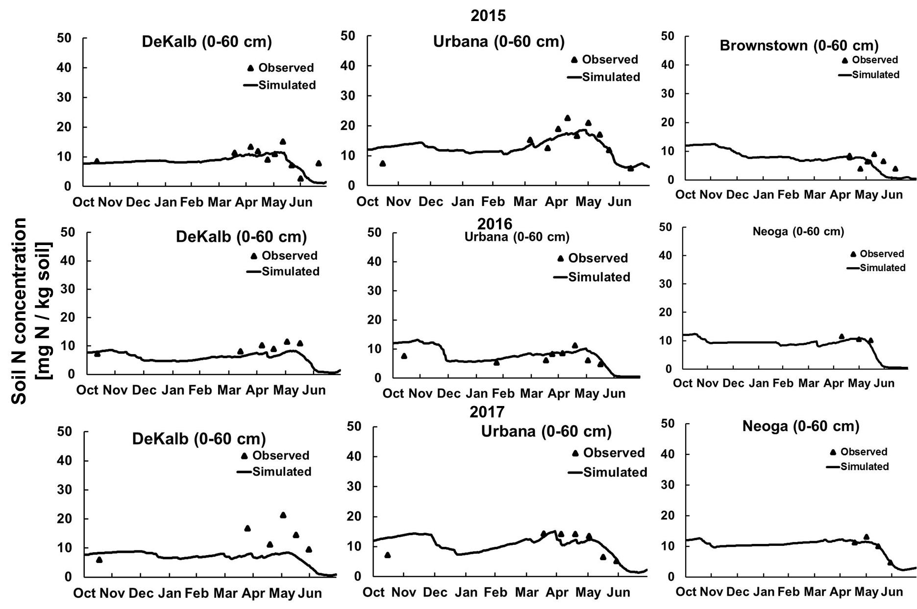

**Fig. 1.** Comparison of observed and DSSAT simulated soil N concentration (mg N kg soil-1) at 0–60 cm in the control treatment for three field experiments (DeKalb, Urbana, Brownstown/Neoga) during 2015–2017.

The ability to estimate SOM mineralization is a key step in improving fertilizer N use efficiency due to its large contribution to inorganic soil N pools and crop N uptake. In the control treatment, soil N concentration ranged from 2.6 to 22.5 mg N kg soil-1 which showed a slight increase in April and May due to increased SOM mineralization associated with warm, wet weather (Fig. 1). DSSAT accurately predicted that soil N concentration for control plots was 100% greater in Urbana (> 20 mg N kg soil-1) than Brownstown (< 10 mg N kg soil-1) during April and May 2015, while no such difference was found in 2016. At the Urbana experimental site, soil N concentration at the time of maize planting was two-fold greater in 2015 than 2016, likely because high rainfall events in 2016 caused substantial N losses from the 0–60 cm soil depth. Based on our simulations, predicted net SOM mineralization in the maize growing season ranged between 66.3–193.1, 57.2–224.5, and 63.5–201.5 kg N ha-1 across the three experimental sites in 2015, 2016, and 2017, respectively.

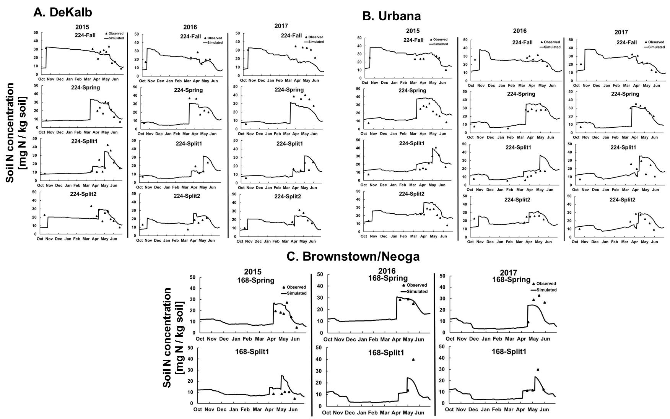

**Fig. 2.** Comparison of observed and DSSAT simulated soil N concentration (mg N kg soil-1) at 0–60 cm for four (DeKalb and Urbana) or two (Brownstown/Neoga) N fertilizer management treatments during 2015–2017. 224-Fall (224 kg N ha-1 applied as anhydrous ammonia in fall); 224-Spring (224 kg N ha-1 applied as anhydrous ammonia in spring); 224-Split1 (56 kg N ha-1 applied as anhydrous ammonia in spring + 168 kg N ha-1 applied as UAN at V5 stage), 5) 224-Split2 (112 kg N ha-1 applied as anhydrous ammonia in fall + 56 kg N ha-1 applied as UAN each at V5 and V9 stages).

These SOM mineralization predictions are within the range estimated by other researchers using a variety of methods in other maize production systems. In the present study, net SOM mineralization in the maize growing season was 2.9–3.9 fold greater at Urbana (193.1224.5 kg N ha-1 year-1) than Brownstown 57.2–66.3 kg N ha-1 year-1), demonstrating that substantial spatial variations can occur between fields. Accurately accounting for this variability in SOM mineralization is necessary to predict soil N concentration under a variety of soil and climate conditions, given that inorganic soil N availability is the net balance of multiple soil N cycling processes (e. g. SOM mineralization, N fertilizer transformations, crop N uptake, and environmental losses).

*Effect of N fertilizer treatments on soil N status*

Following fall N application at DeKalb and Urbana, soil N concentration remained > 30 mg N kg soil-1 in November and December during the study period (Fig. 2). Both the model and field data showed that soil N concentration decreased between the time of fall N application and maize planting, suggesting an environmental loss of fall-applied N. The difference in soil N concentration between 224-Spring and 224-Fall at the time of maize planting was 5.9–11.2 mg N kg soil-1 in model predictions compared with 1.0–4.4 mg N kg soil-1 in field observations, indicating that the model overestimated the environmental loss of fall-applied N during 2015–2017. At the time of maize planting, the difference in soil N concentration between 224-Spring and 224-Fall was greater in 2016 and 2017 compared to 2015 (Fig. 2). Previous studies have shown divergent conclusions on the effectiveness of fall and spring application times on soil N availability and maize grain yield in the US Midwest. Our results provide additional evidence that differences in soil N concentration due to fertilizer application timing are not consistent every year, which can make it difficult for farmers to assess crop yield penalties due to soil N availability. However, a positive finding of this study is that DSSAT was able to capture these changes in soil N concentration in response to fertilizer application timing across sites in two of three years, suggesting this model could potentially be used as a management tool to estimate the effectiveness of fall vs spring application on soil N concentration at critical stages during the maize growth season.

Unlike soil N changes over the winter, soil N concentration declined sharply in spring due to simultaneous crop N uptake and environmental losses caused by the comparatively wetter and warmer spring weather (Fig. 2). At three experimental sites, DSSAT performed reasonably well in predicting the magnitude of soil N decline between maize planting and mid-June in response to different fertilizer treatments (Fig. 3). Across 224-Fall and 224-Spring treatments at Urbana and DeKalb, soil N concentration decreased by 12.9–38.1% between maize planting and mid-June in the field observations, compared with a 1.0–55.7% reduction in model predictions. Farmers are often concerned with having sufficient soil N supply to meet crop N demand at the time of rapid uptake, which can often start around mid-June in Illinois maize production systems. In this study, DSSAT was able to estimate the decrease in soil N concentration following early spring weather conditions that were conducive to N loss, particularly in 2015, suggesting that the model has the potential to provide information which may assist farmers in making in-season N management decisions.

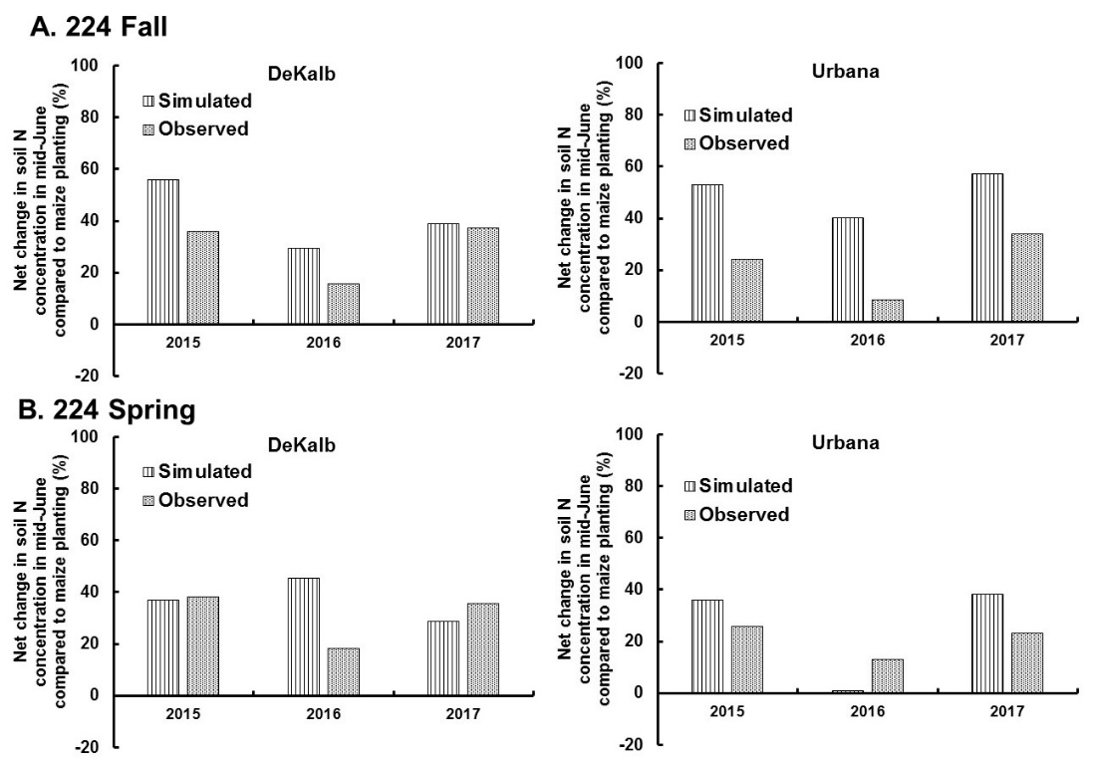

**Fig. 3.** Comparison of observed and DSSAT simulated net change in soil N concentration in mid-June compared with maize planting date for two field experiments (DeKalb and Urbana) during 2015–2017. 224-Fall (224 kg N ha-1 applied as anhydrous ammonia in fall); 224-Spring (224 kg N ha-1 applied as anhydrous ammonia in spring).

*Model validation in commercial maize fields*

A major strength of this research is that DSSAT performance was additionally evaluated against soil N observations from 49 farmers’ fields, most of which were situated in northern and central Illinois. Few studies have attempted to calibrate a process-based model for predicting soil N concentration in the US Midwest, and we are unaware of any modeling efforts where a large, independent dataset derived from commercial maize fields was used as an additional validation step. Across the 49 sites with different fertilizer management scenarios, soil N concentration ranged from 6.0–55.5 mg N kg soil-1, with a mean value at the time of maize planting of 26.7±13.4 mg N kg soil-1 at 0­–60 cm (Fig. 4).

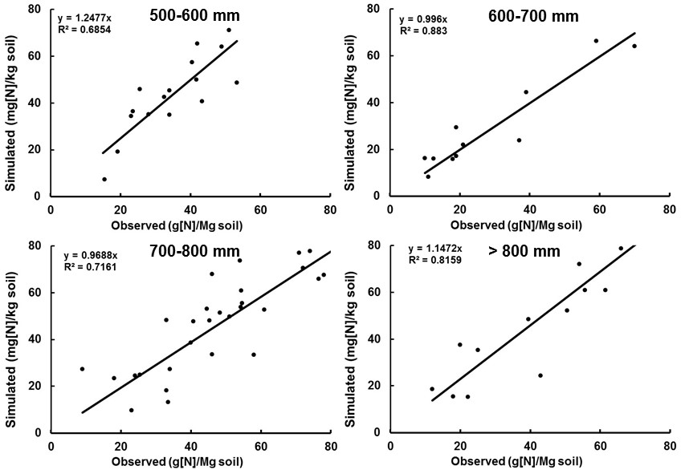

**Fig. 4.** Comparison of observed and DSSAT simulated soil N concentration at 49 commercial maize fields in Illinois. Field sites were categorized according to cumulative precipitation occurring between January and July in 2015 and 2016.

It is well-established that early season rainfall amounts have significant impacts on environmental loss of fertilizer N from maize production systems. Across four cumulative rainfall categories, DSSAT was able to predict soil N concentration in farmer’s fields with a relatively high R2 value of 0.68–0.88 and slope of 0.99–1.24 (Fig. 4). Across the 49 fields, an nRMSE value of 21.2% suggested that DSSAT had “fair” performance in predicting the effect of fertilizer treatments on soil N concentration in the maize growing season. The D-index value 0.91 suggested that variation in soil N concentration is closely related to the variation in the predicted field data. The CRM index value of 0.017 indicated the model slightly underestimated soil N concentration as compared to field observations.

**Listing of papers and conference presentations resulting from this project**

Banger, K., Yuan, M., Wang, J., Nafziger, E.D., Pittelkow, C.M. 2017. A vision for incorporating environmental effects into nitrogen management decision support tools for U.S. maize production. Frontiers in Plant Science 8:1270.

Banger, K., Nafziger, E.D., Wang, J., Muhammad, U., Pittelkow, C.M. 2018. Simulating nitrogen management impacts on maize production in the U.S. Midwest. PLoS ONE 13(10): e0201825.

Banger, K., Nafziger, E.D., Wang, J., Pittelkow, C.M. Modeling soil nitrogen status in Illinois maize production systems. Soil Science Society of America Journal. Under review.

Conference presentations

Banger, K., Nafziger, E., Wang, J., Pittelkow, C.M. 2015. Developing a nitrogen loss decision support tool for Illinois. Poster presentation. ASA-CSSA-SSSA Conference, Nov 15-18, 2015. Minneapolis, Minnesota.

Banger, K., Pittelkow, C.M., Wang, J., Nafziger, E.D., Umar, M. 2016. Simulating soil N availability and loss in Illinois corn production systems. Invited symposium presentation. ASA-CSSA-SSSA Conference, Nov 6-9, 2016. Phoenix, Arizona.

Preza Fontes, G., Nafziger, E.D., Pittelkow, C.M. 2018. Does in-season soil nitrogen concentration predict maize yield response? Oral presentation. ASA-CSSA-SSSA Conference, Nov 4-7, 2018. Baltimore, Maryland.